Practicle 1

Program 1:

Code:

/* Program1 : WAP to take check ehether the input is a leap year or not

*/

#include<stdio.h>

void main() {

int year;

printf("Enter year:");
scanf("%d",&year);

if( (year%400==0) || ((year%4 == 0) && (year%100!=0)))
printf("%d is a leap year\n",year);
else
printf("%d is not a leap year\n",year);

}

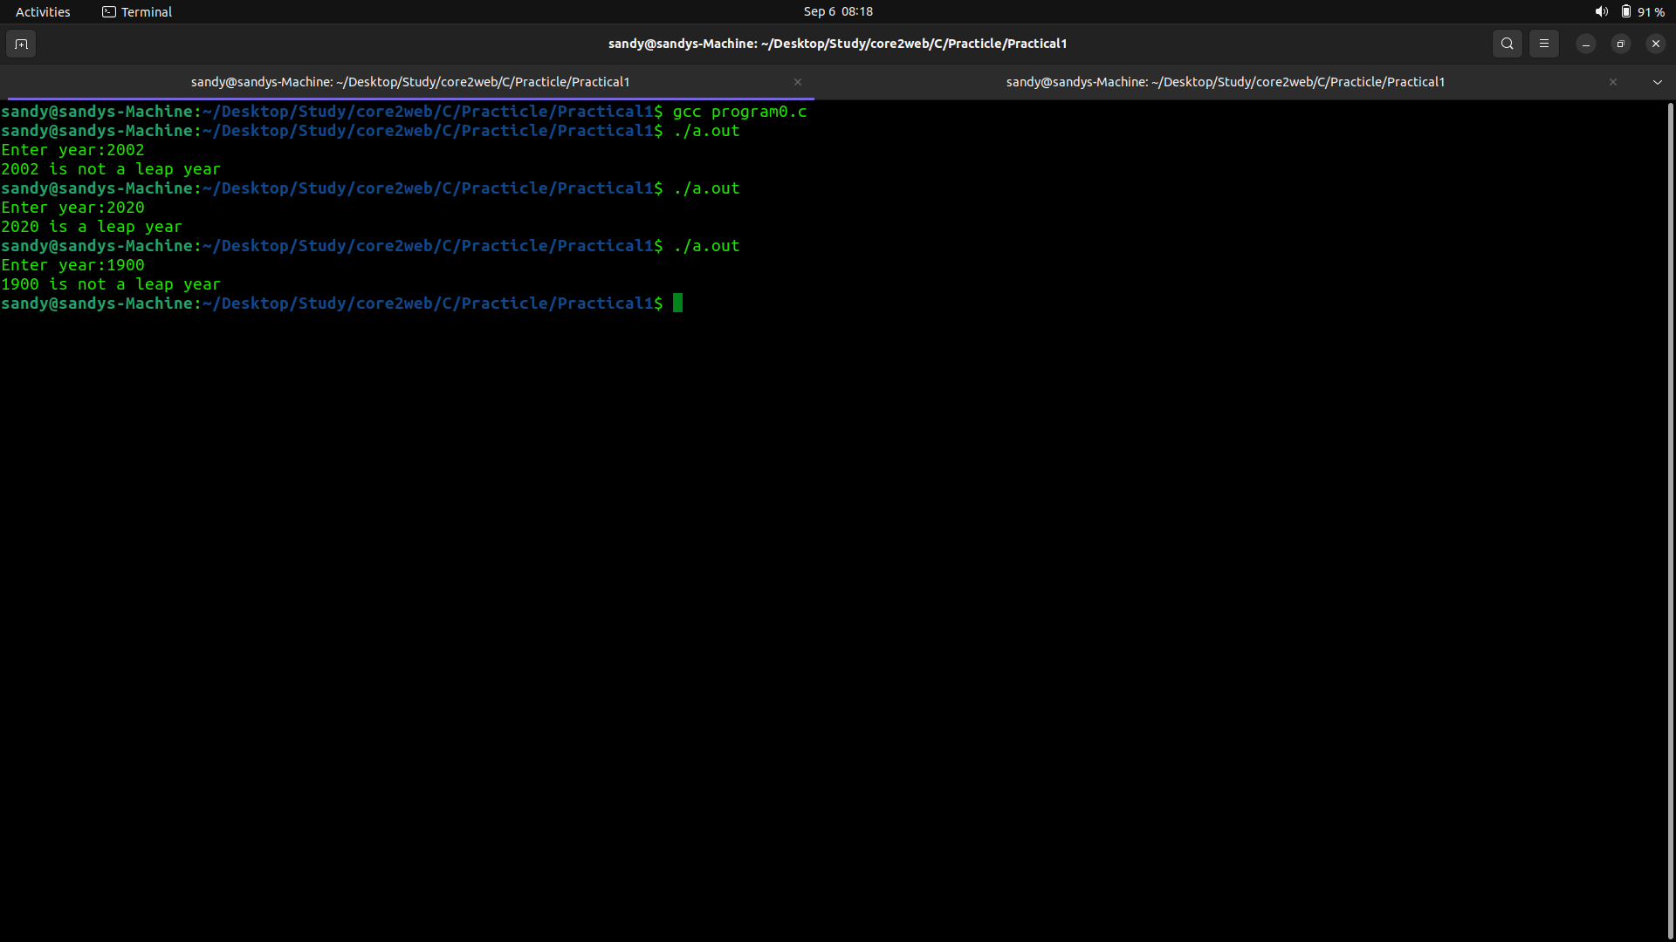

Program 2:

Code:

/* Program2 WAP to find max among 3 numbers
*
* */

#include<stdio.h>

void main() {

int num1,num2,num3;

printf("Enter three numbers :");
scanf("%d %d %d",&num1,&num2,&num3);
if(num1 == num2 && num1 == num3) {
printf("%d , %d and %d are eual numbers\n",num1,num2,num3);

}else {

if(num1 > num2 && num1 > num2)
printf("max number is %d\n",num1);
else if(num2 > num3)
printf("max number is %d\n",num2);
else
printf("max number is %d\n",num3);
}

}
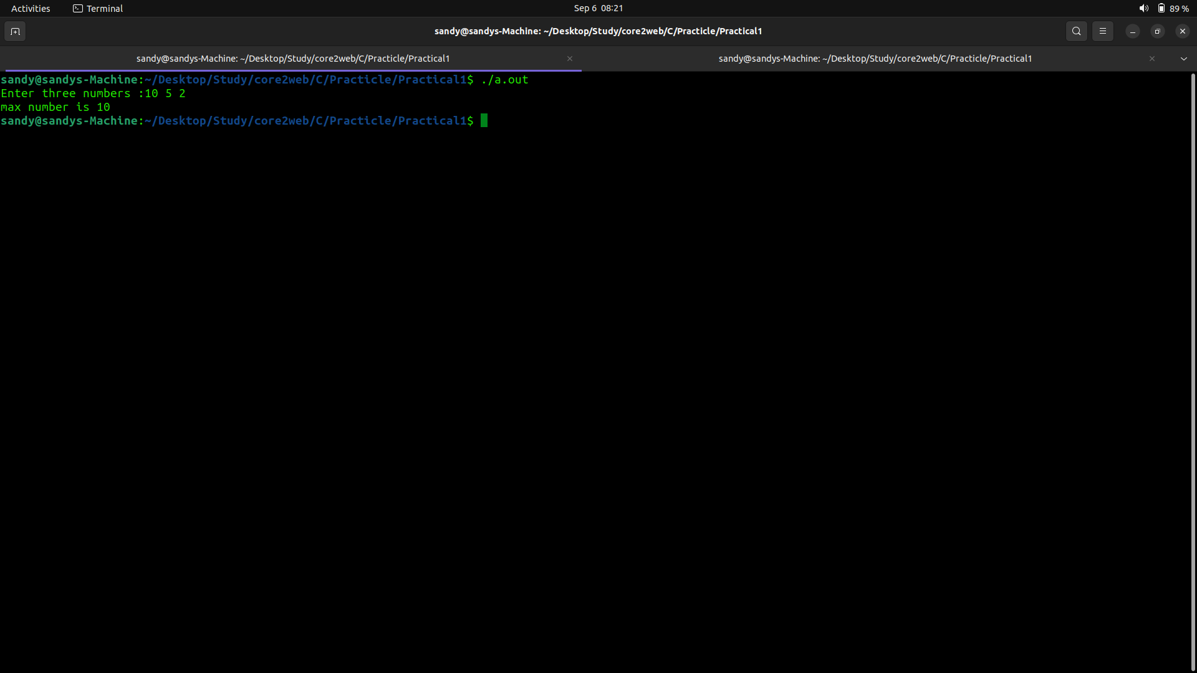
Program 3:

Code:

/*
* Program2 WAP to find min among 3 numbers
* */

#include<stdio.h>

void main() {

int num1,num2,num3;

printf("Enter three numbers :");
scanf("%d %d %d",&num1,&num2,&num3);
if(num1 == num2 && num1 == num3) {
printf("%d , %d and %d are eual numbers\n",num1,num2,num3);
}else {

if(num1 < num2 && num1 < num2)
printf("min number is %d\n",num1);
else if(num2 < num3)
printf("min number is %d\n",num2);
else
printf("min number is %d\n",num3);
}

}
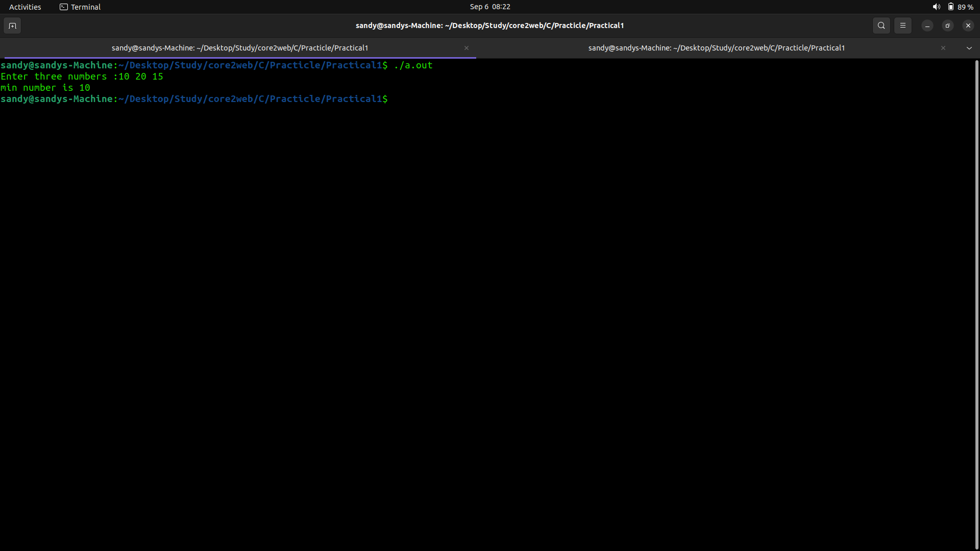
Program 4:

Code:

/*
* program 4:write a program according to the month number print the no of days in that months
*
*/

#include<stdio.h>

void main() {

int month;

printf("Enter month:");
scanf("%d",&month);

switch(month) {

case 1:
printf("January has 31 days\n");
break;
case 2:
printf("February has 28 or 29 days\n");
break;
case 3:
printf("March has 31 days\n");
break;
case 4:
printf("April has 30 days\n");
break;
case 5:
printf("May has 31 days\n");
break;
case 6:
printf("June has 30 days\n");
break;
case 7:
printf("July has 31 days\n");
break;
case 8:
printf("August has 31 days\n");
break;
case 9:
printf("September has 30 days\n");
break;
case 10:
printf("October has 31 days\n");
break;
case 11:
printf("November has 30 days\n");
break;
case 12:
printf("December has 31 days\n");
break;
default:
printf("You entered invalid onth\n");
break;
}}

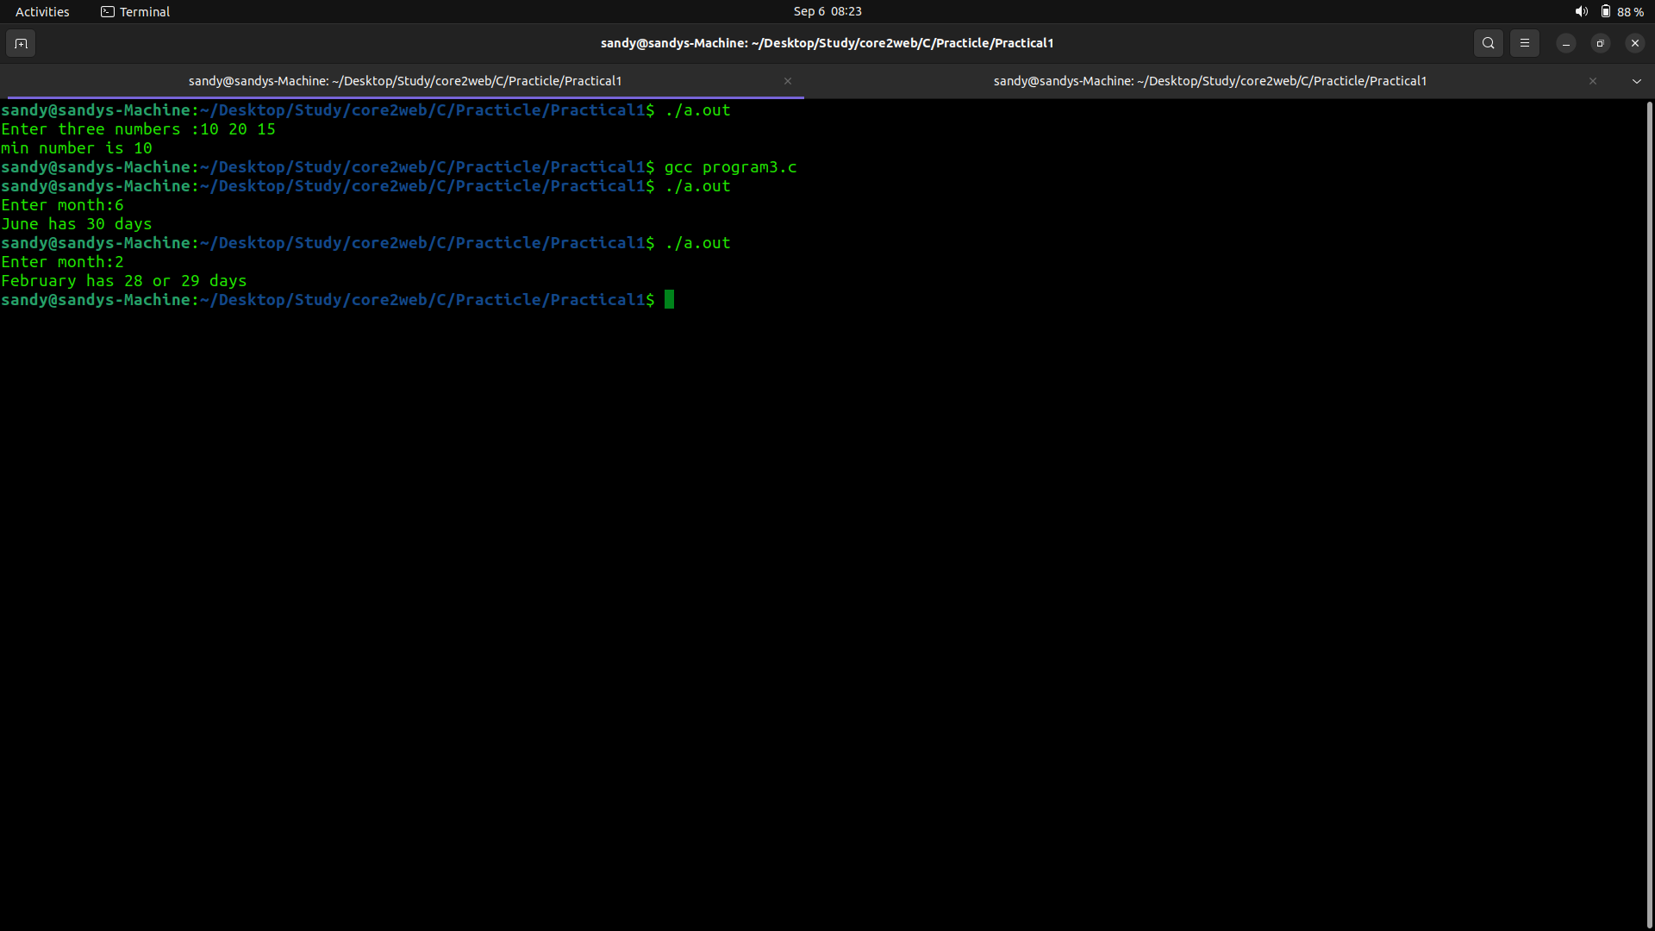

Program 5:

Code:

/*
* Program 5: Write a program that takes a number from 0 to 5 and prints its spelling
* if the number is greater than 5 print entered number is greater than 5
*/

#include<stdio.h>

void main() {
int num;

printf("Eter number:");
scanf("%d",&num);
switch(num) {
case 0:
printf("Zero\n");
break;
case 1:
printf("One\n");
break;
case 2:
printf("Two\n");
break;
case 3:
printf("Three\n");
break;
case 4:
printf("Four\n");
break;
case 5:
printf("Five\n");
break;

default:
if(num>5)
printf("%d is greater than 5\n",num);
else
printf("Enter number greater than 0\n");
break;
}}

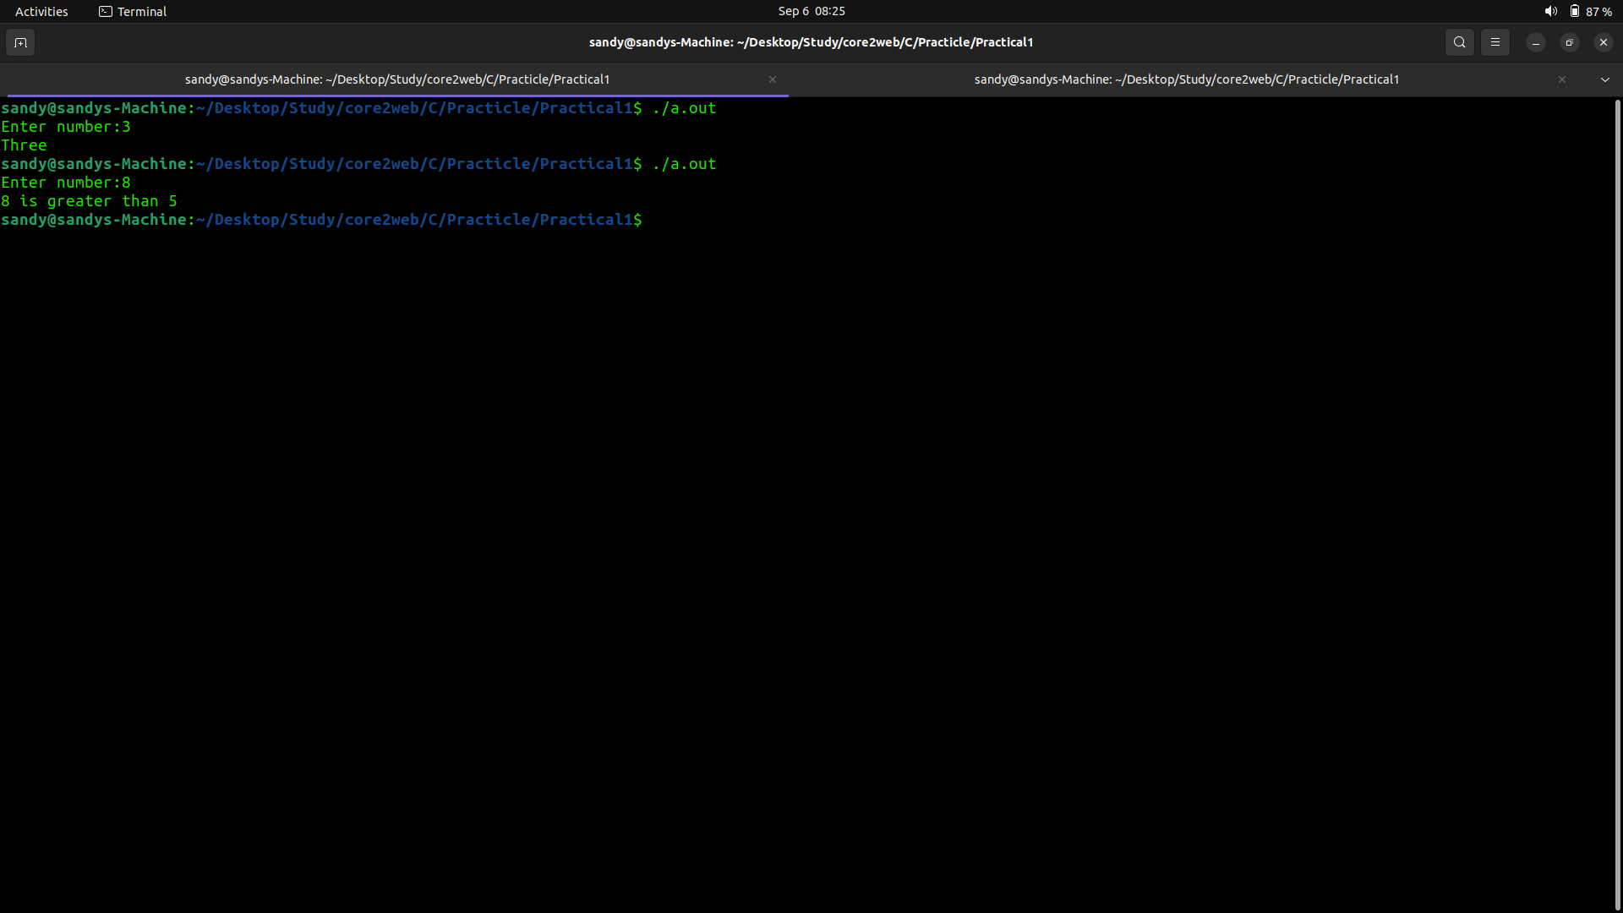
Program 6:

Code:
/*
* Program 6: WAP to get 10 nubers from user and fint thei avg and sum
*/

#include<stdio.h>

void main() {

int num,sum=0;
float avg;

for(int i=1;i<=10;i++) {

printf("Enter number %d:",i);
scanf("%d",&num);

sum = sum + num;
}

avg = (float)sum / 10;
printf("Sum:%d\nAverage:%.2f\n",sum,avg);
}

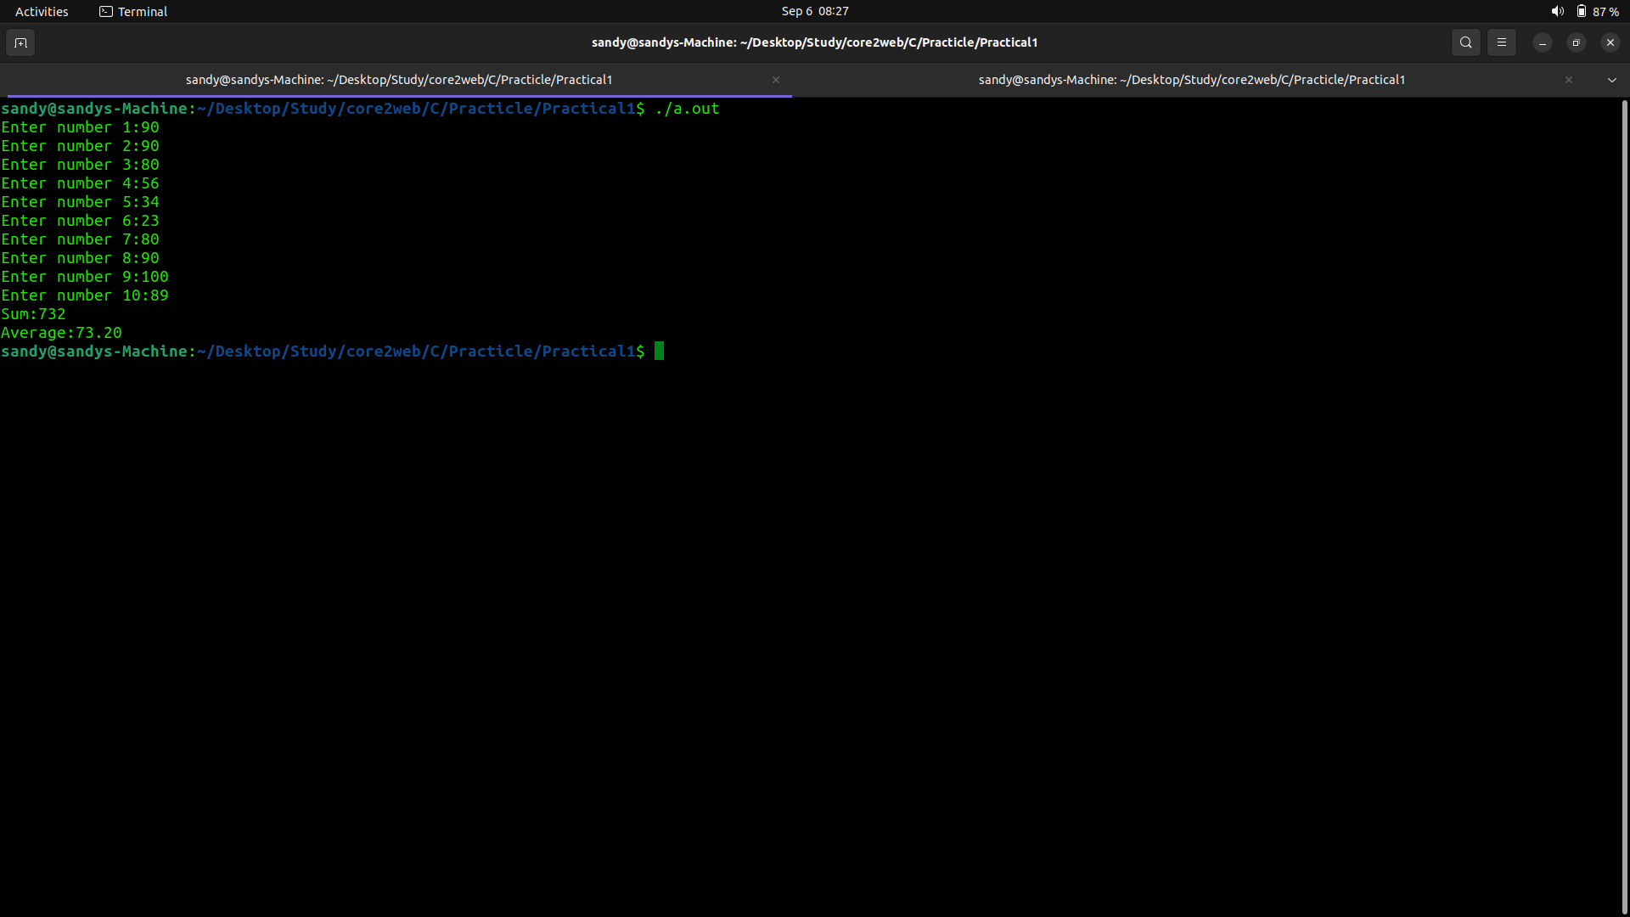

Program 7:

Code:
/*
* Program 7: WAP to check weather given input is a pythagorean triplate or not
*/

#include<stdio.h>

void main() {

int a,b,c;

printf("Enter value of a ,b and c :");
scanf("%d %d %d",&a,&b,&c);

int hypo;

if(a>b && a>c ) {
hypo = a;
a = b;
b = c;
}
else if(b>c) {

hypo = b;
b = c;
}else {

hypo = c;
}

if(a*a + b*b == hypo*hypo) {

printf("following is pythagorean triplate...\n");

}else {

printf("following is not a pythagorean triplate...\n");
}

}

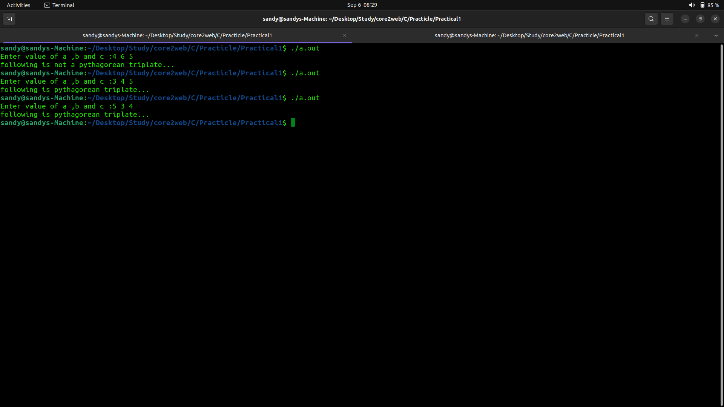

Program 8:

Code:

/*
* program 8 : WAP taht takes angles of a triangle from user and print weather the angle is valid or not
*
*/

#include<stdio.h>

void main() {

int angle1,angle2,angle3;

printf("Enter angle1:");
scanf("%d",&angle1);

printf("Enter angle2:");
scanf("%d",&angle2);

printf("Enter angle3:");
scanf("%d",&angle3);

if(angle1+angle2+angle3 == 180)
printf("The is a valid triangle\n");
else
printf("The is not a valid triangle\n");

}

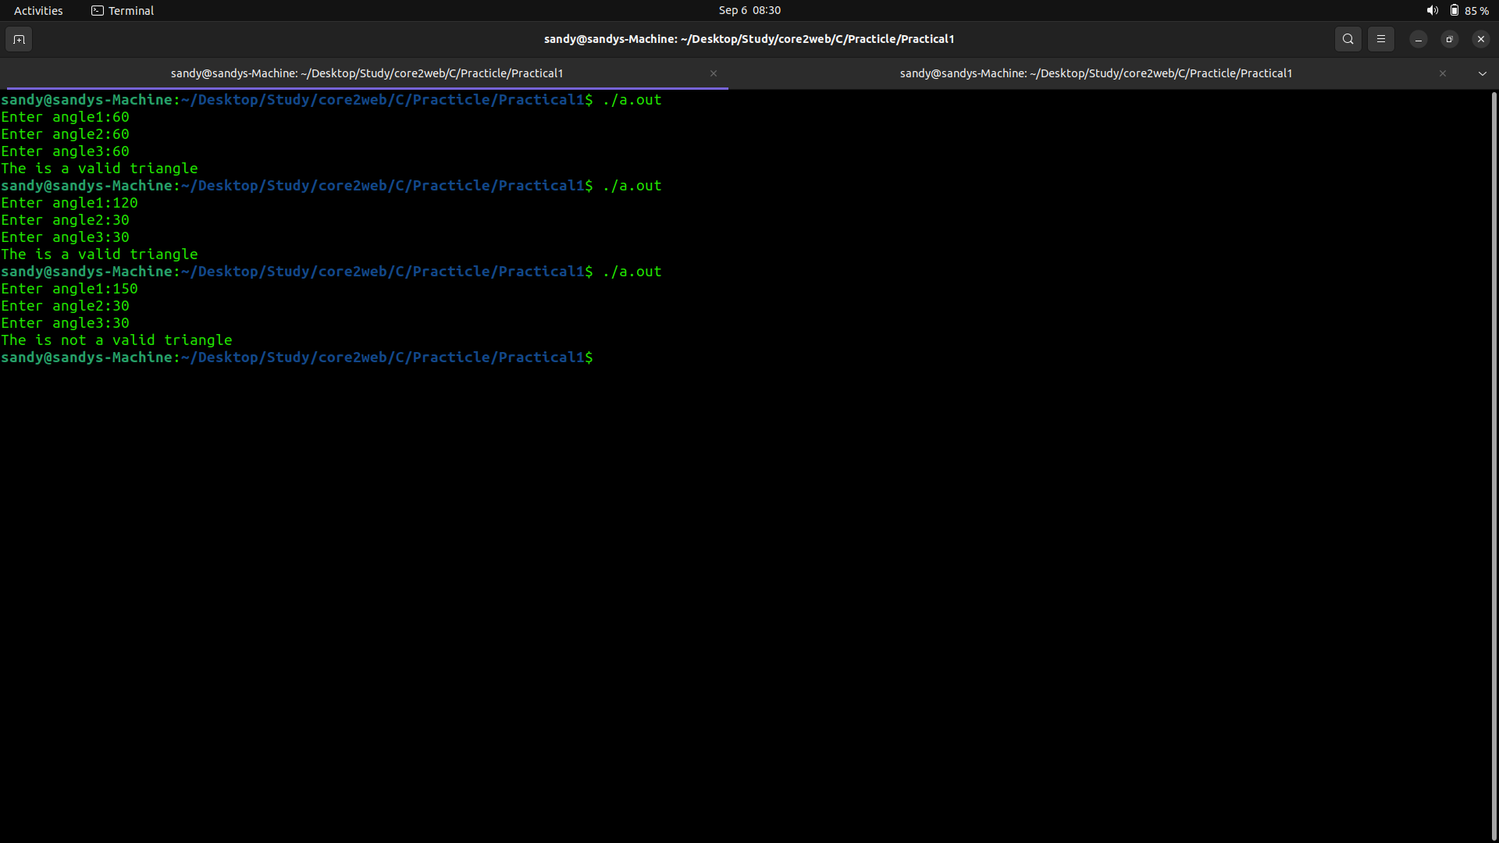

Program 9:

Code:

/*
* Program 9: Print all divisors of entered number
*/

#include<stdio.h>

void main() {

int num;

printf("Enter a number:");
scanf("%d",&num);

if(num<=0) {
printf("Enter positive numbers only...\n");
}else {

printf("All divisors of %d are:\n",num);
for(int i=1;i<=num/2;i++) {

if(num%i==0)
printf("%d\n",i);
}

}
}

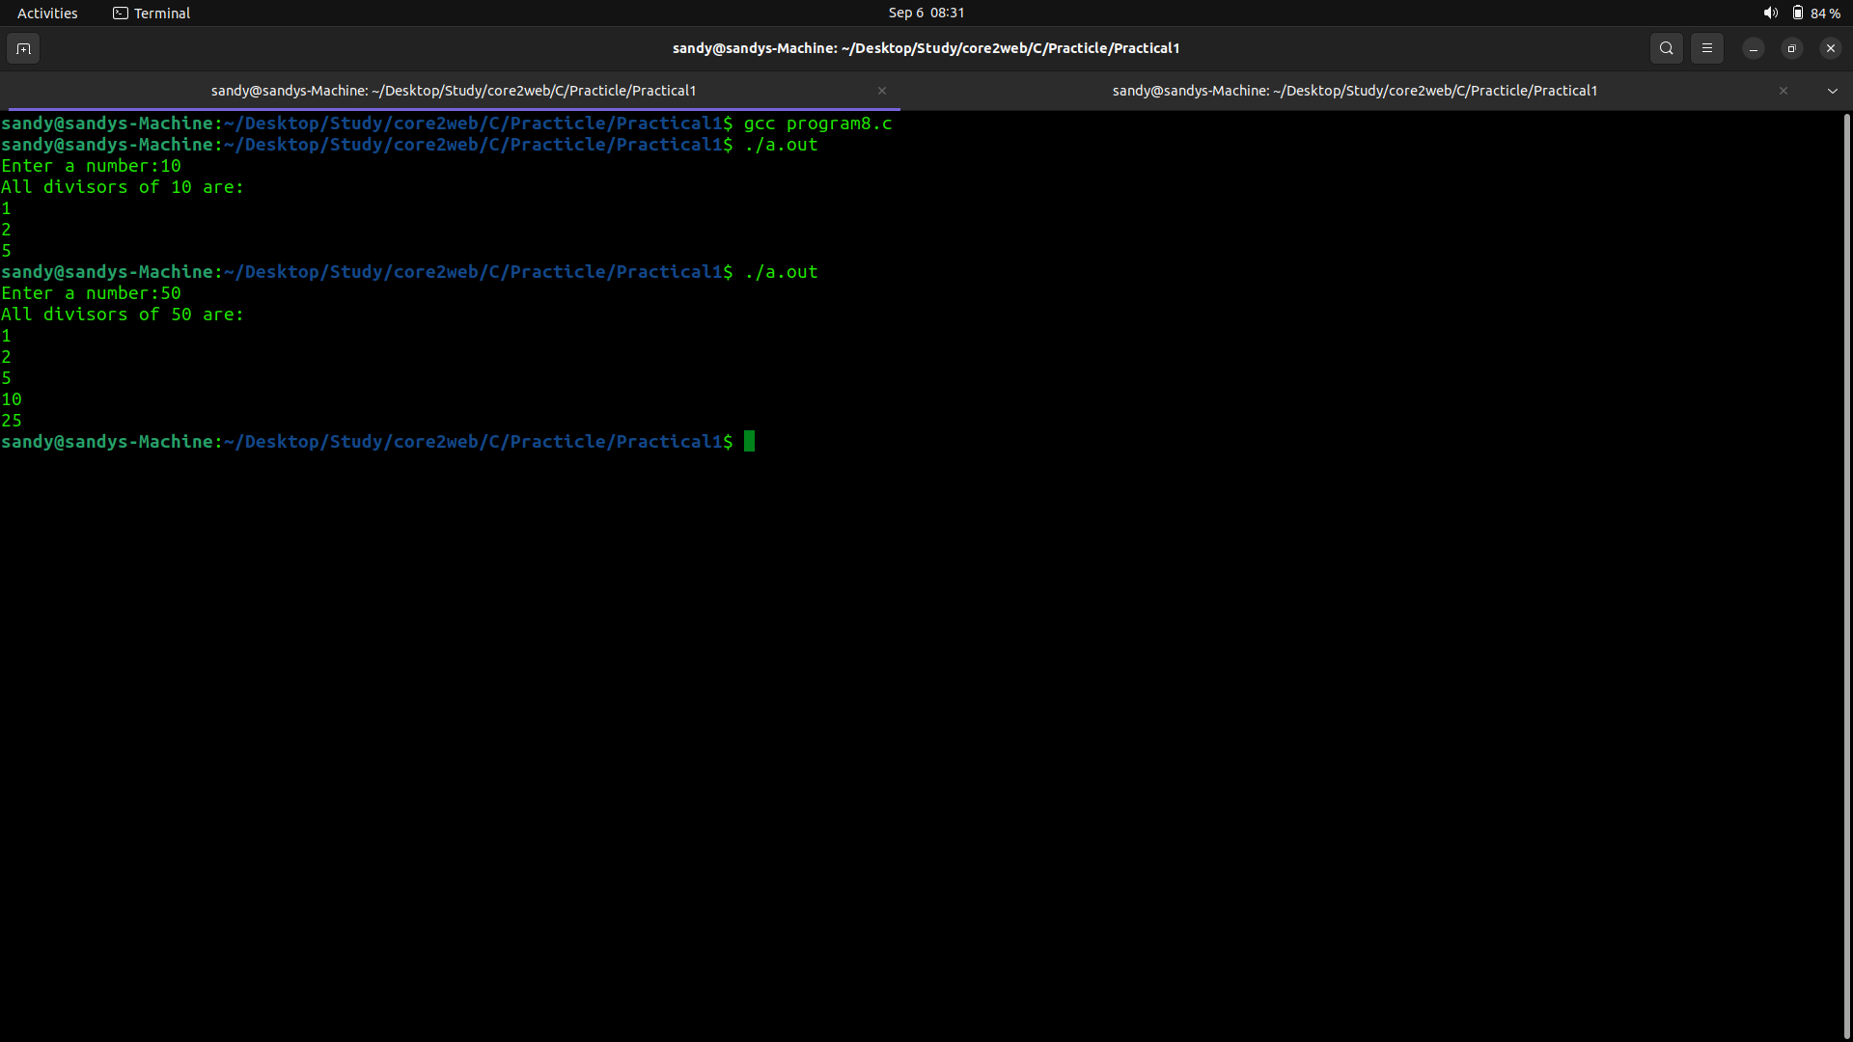

Program 10:
Code:

/*
* Program 10: WAP take two characters if these characters are equal then print them as it is but if they are unequal then print their difference
*/

#include<stdio.h>

void main() {

char ch1,ch2;

printf("Enter character 1:");
scanf("%c",&ch1);

printf("Enter character 2:");
scanf(" %c",&ch2);

if(ch1 == ch2)
printf("ch1:%c\tch2:%c\n",ch1,ch2);
else {

if(ch1>ch2)
printf("The difference between %c and %c is :%d\n",ch1,ch2,ch1-ch2);
else
printf("The difference between %c and %c is :%d\n",ch1,ch2,ch2-ch1);

}
}
